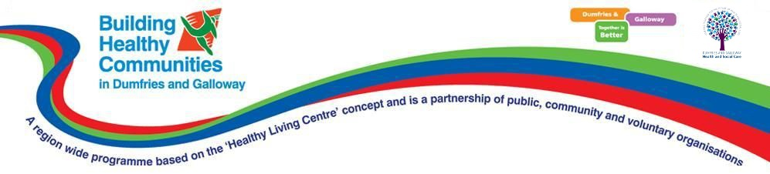**Building Healthy Communities**

**Preliminary Website Guide**

## Introduction

This is a guide to the Building Healthy Communities system, used to administer the various users and initiatives of the BHC programme. As the system is still under active development, this is only a preliminary guide designed to help with use of the currently existing features. When the system is complete, a more detailed and comprehensive guide will also be created.

## System Access and Login

At present, the system is hosted on a website called Heroku. The link to the site is as follows: <https://hidden-mountain-49766.herokuapp.com/>

When the system is accessed, you will be presented with this webpage:

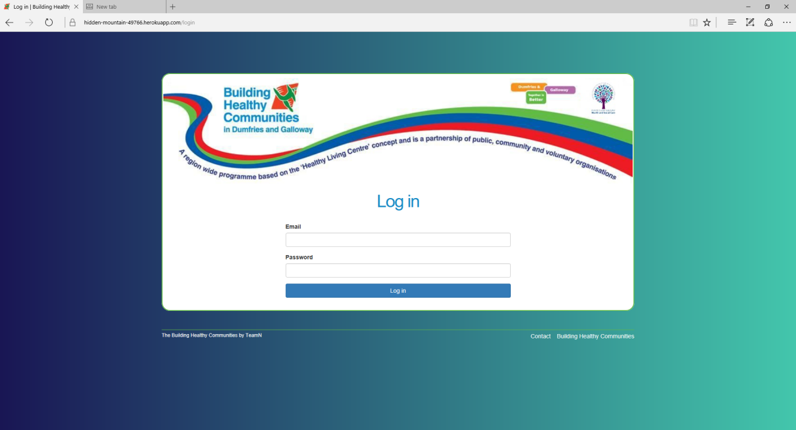

This is the only page accessible on the site until you log in. Log in using your admin, volunteer, or service user details, depending on what you want to access.

## Administrator - Homepage

Administrators are the only users with access to the entire system. They have privileges to add, delete, and modify the details of service users, volunteers, initiatives, medical conditions, and feedback questions. If you logged in as an administrator, this will be the first page you are presented with:

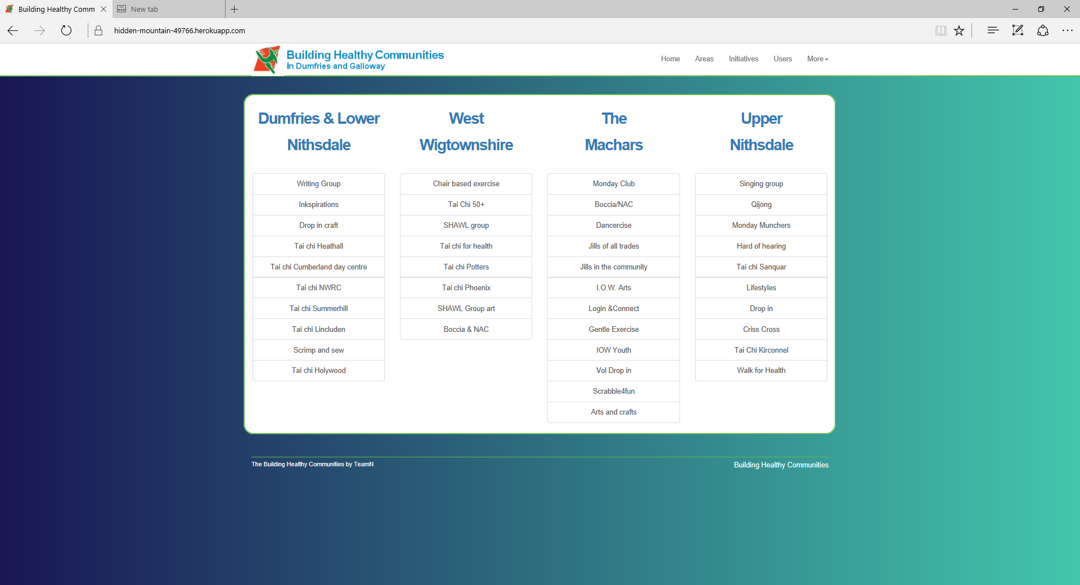

This is the home page, a simple overview of the initiatives running in each area. The names of the areas and initiatives are both clickable, and will take you to the page for that area or initiative respectively.

The top bar is also accessible from here, as it is from every page on the website. It gives access to the main page for each major section of the system. Your admin profile page is also accessible from the top bar.

There is quite a lot of information in the administrator of the guide, but a lot of it is easy to get the hang of once you’ve done it once or twice; the various sections are very similar!

## Adminstrator - Areas

Selecting the ‘Area’ button in the top bar loads a page which lists all the areas in a table. You can search this table by area ID and name, though please note that searches are case sensitive. New areas can also be added from this page.

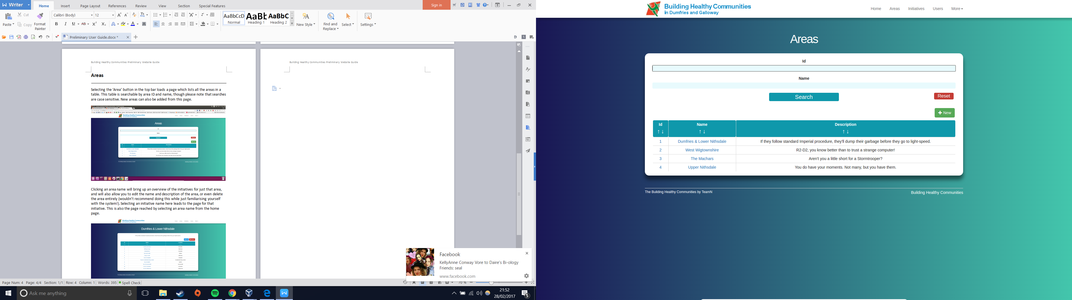

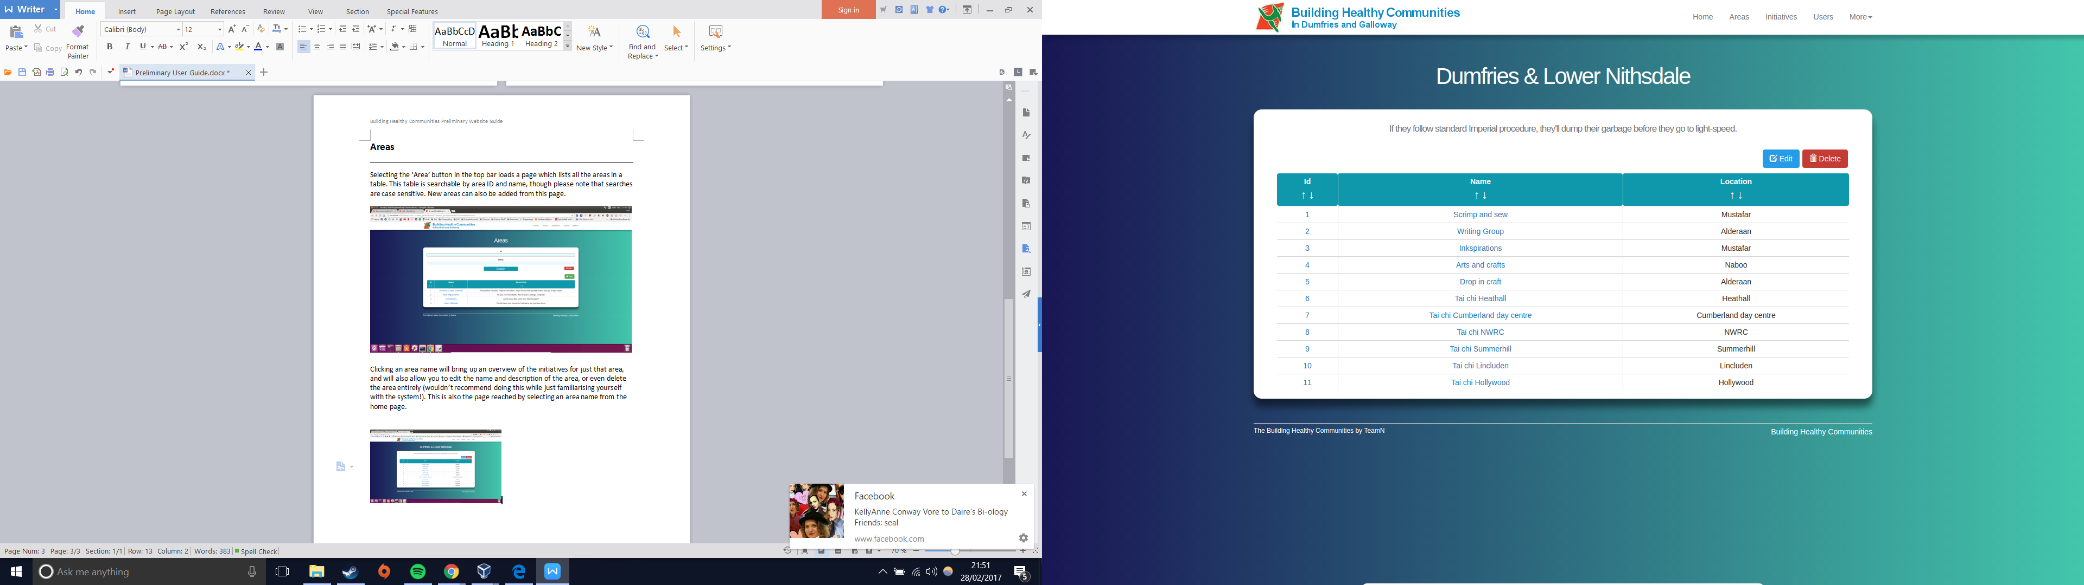Selecting an area name will bring up an overview of the initiatives for just that area, and will also allow you to edit the name and description of the area, or even delete the area entirely (wouldn’t recommend doing this while just familiarising yourself with the system!). Selecting an initiative name here leads to the page for that initiative. This is also the page reached by selecting an area name from the homepage.

## Administrator - Initiatives

Selecting the ‘Initiatives’ button in the top bar loads a page which lists every initiative in a table. You can search this table by initiative ID, name, area, and location, though please note that searches are case sensitive. New initiatives can also be added from this page.

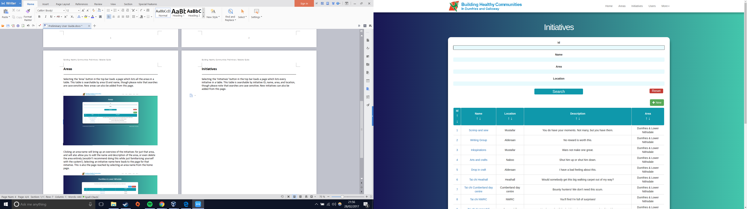

Selecting the name of an initiative will bring up the overview page of that initiative. From here you can edit details of the initiative and view all the members who attend, as well as a list of meetings. New meetings can be created, or the initiative deleted. This is also the page reached by selecting an initiative name from the homepage.

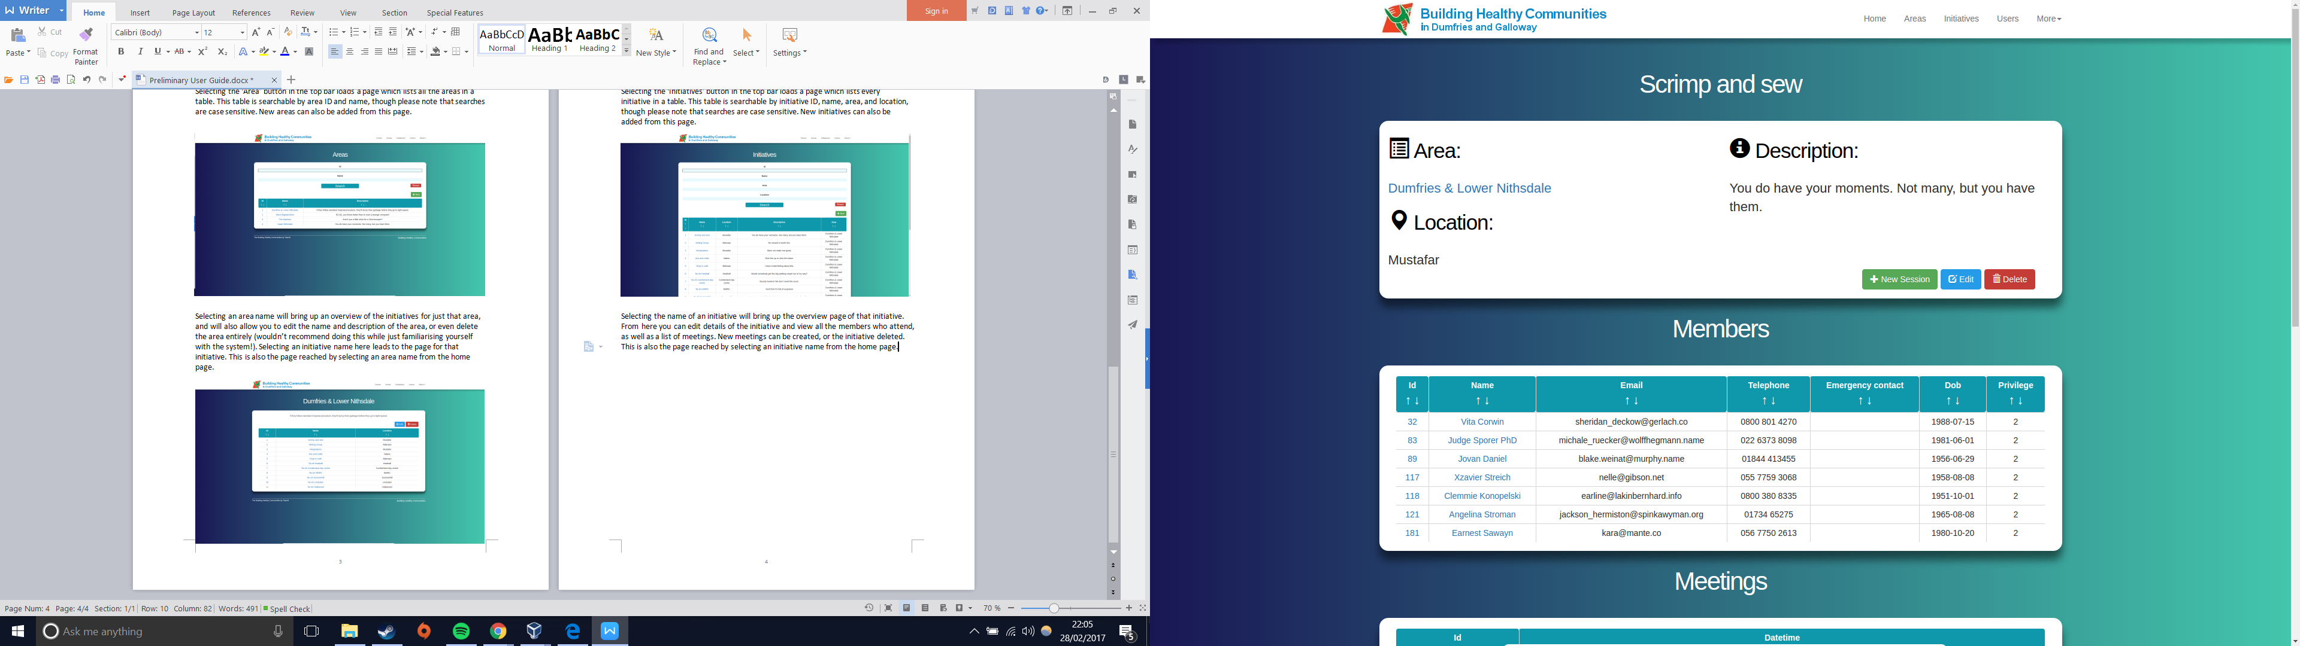

Selecting ‘New Session’ allows you to create a new group of meetings, starting from a particular date and time, and running for an selected number of weeks. Clicking submit takes you to the meeting page for the first meeting in that session, though all will have been added to the initiative’s meeting list.

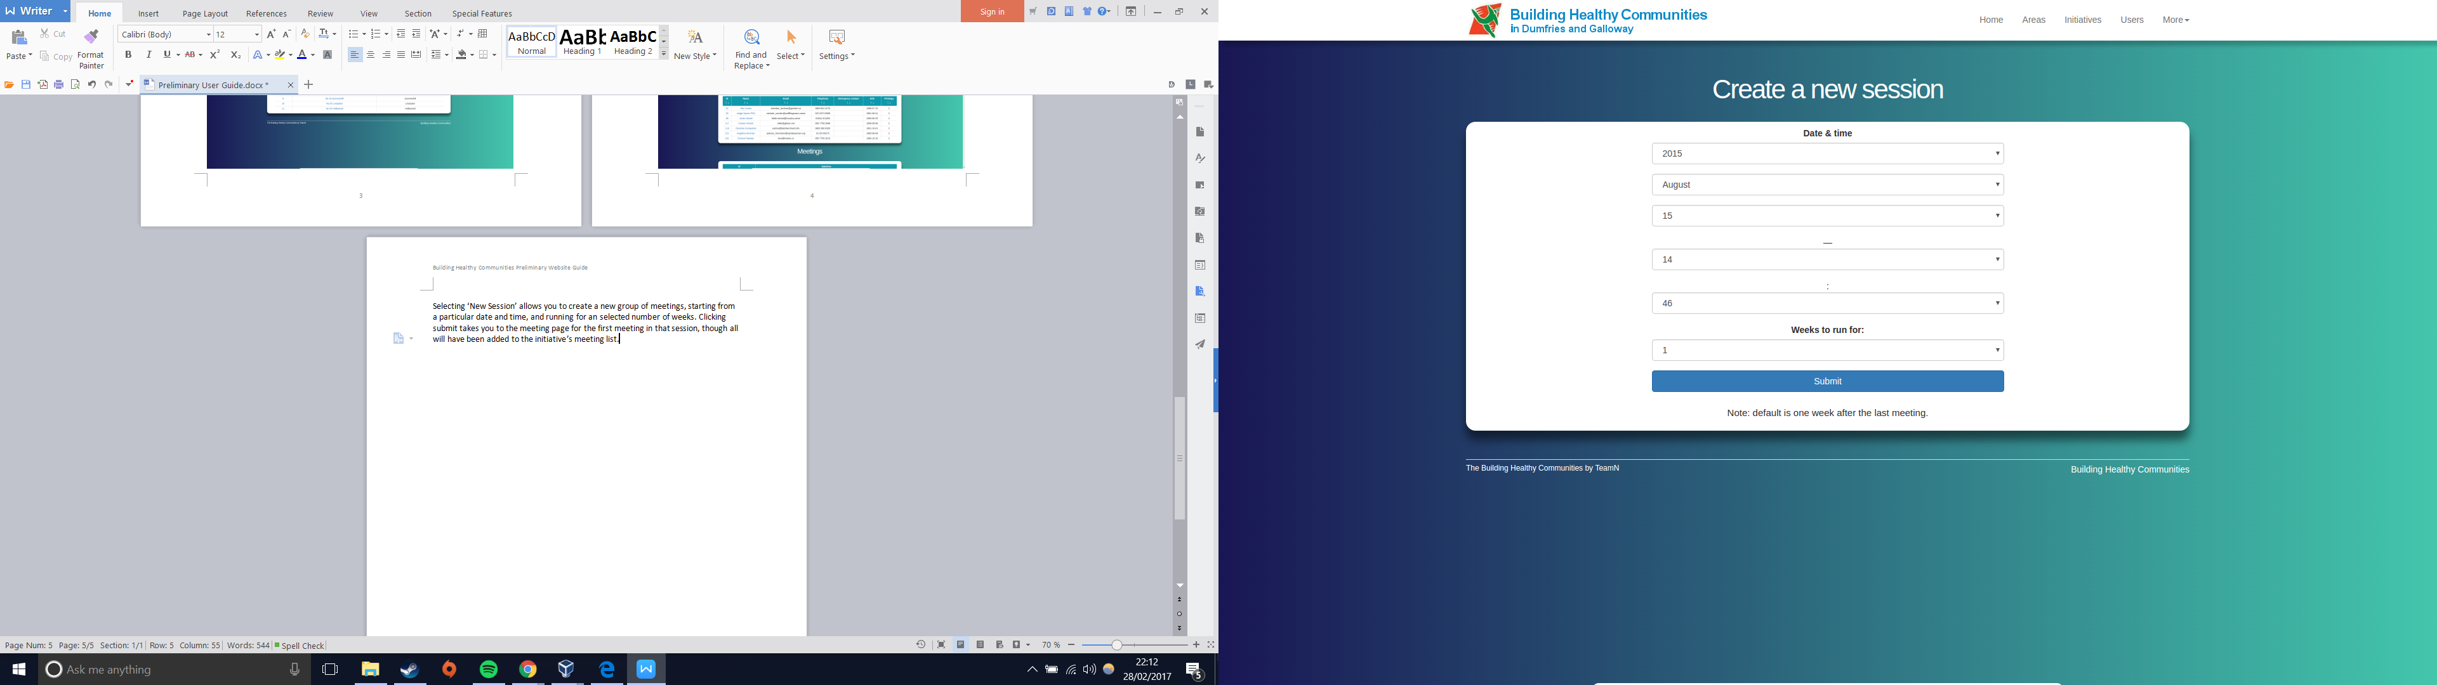

The page displayed when a new session is created, or when a meeting is selected from the list, shows an overview of that meeting. It also contains an attendance list that you can update.

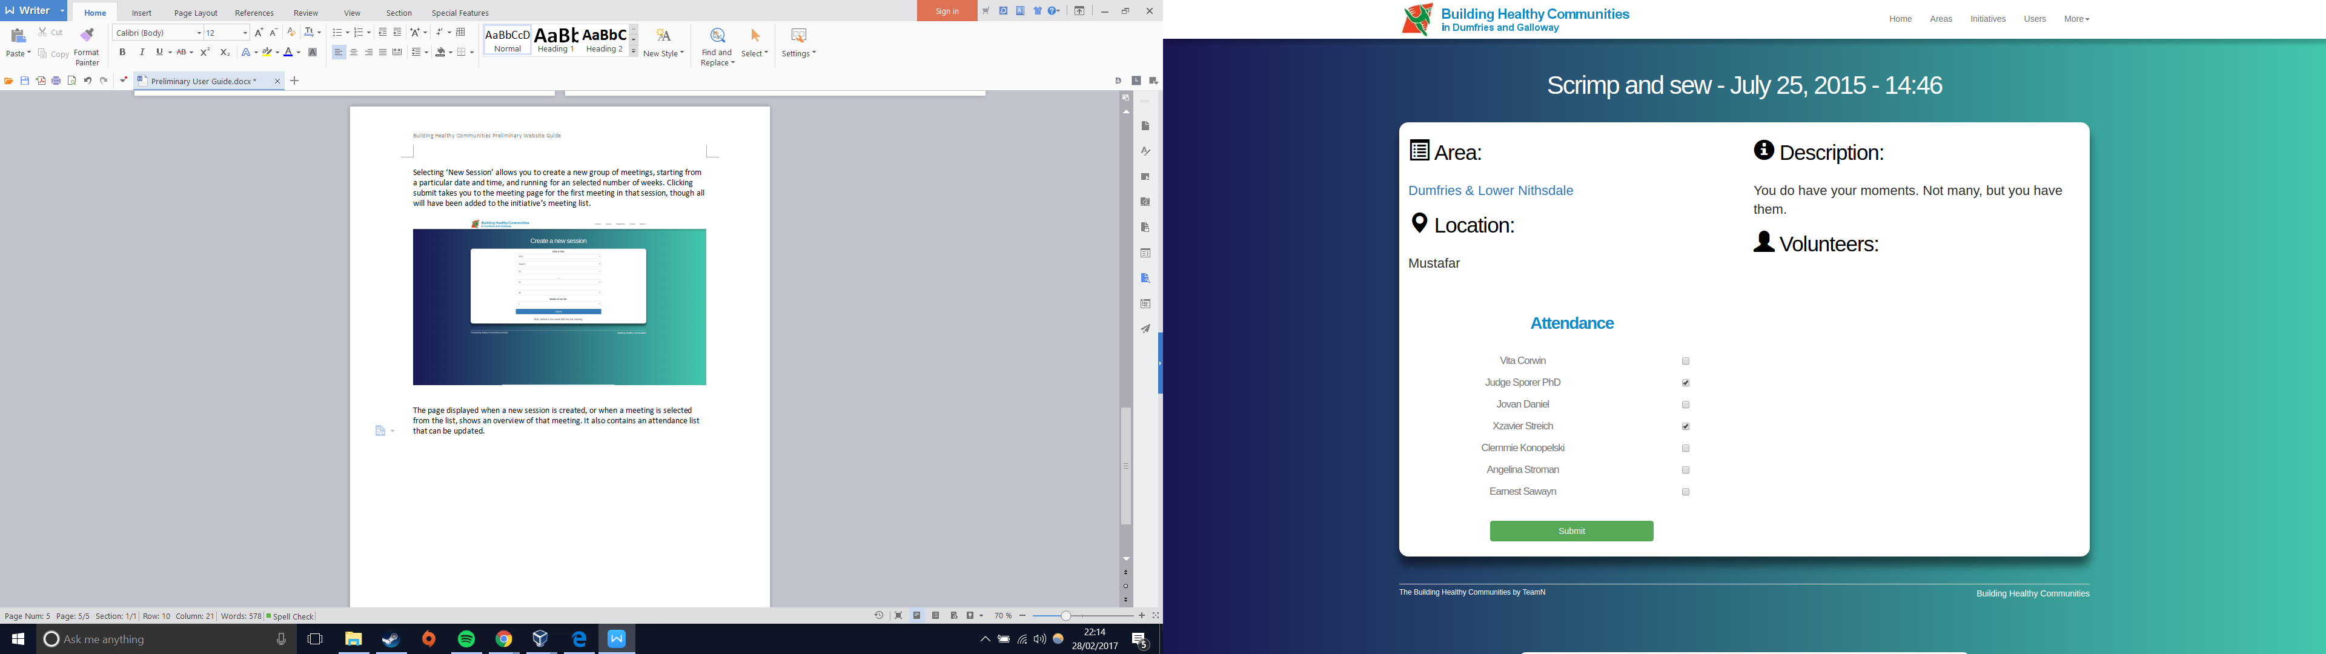

## Administrator - Users

As with the previous two sections, selecting ‘Users’ from the top bar loads a page listing every user in the system, including other administrators. You can search this table in a similar manner to the others. Again, searching is case sensitive. You can also add new members from this page. Note: The privilege of a user determines their role in the system. A privilege of 0 is an administrator, 1 is a volunteer, and 2 is a regular service user.

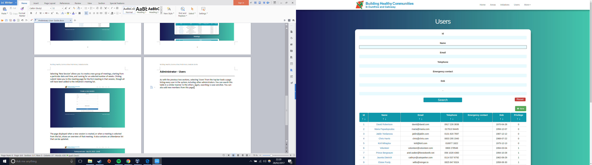

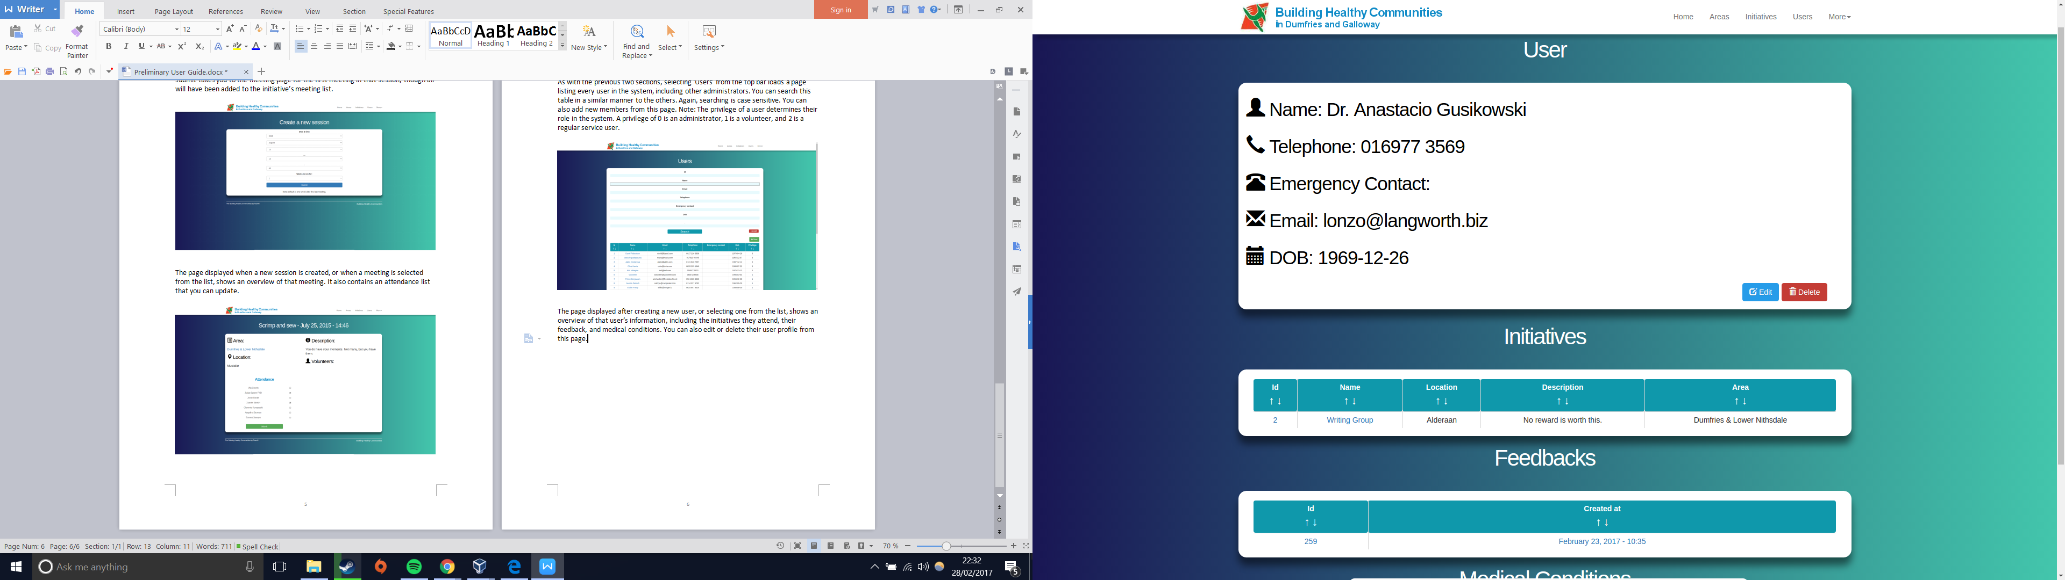The page displayed after creating a new user, or selecting one from the list, shows an overview of that user’s information, including the initiatives they attend, their feedback, and medical conditions. You can also edit or delete their user profile from this page.

## Administrator - User Enrolment

You can access this simple table from the drop down ‘More’ section of the top bar. It can be searched the same way as the other tables, and the ‘New’ button allows you to select a user and enrol them into an initiative.

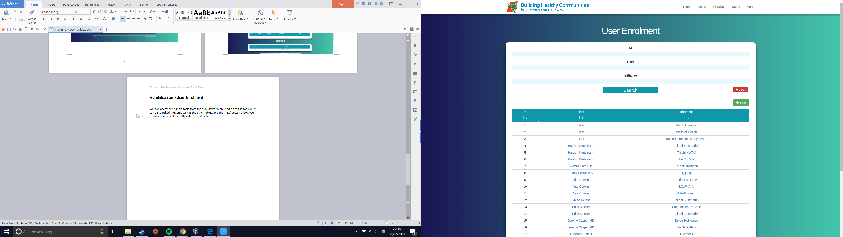

## Administrator - Medical Conditions

Another simple table, this one allows you to see at a glance all the medical conditions in the system, and allows you to add new ones.

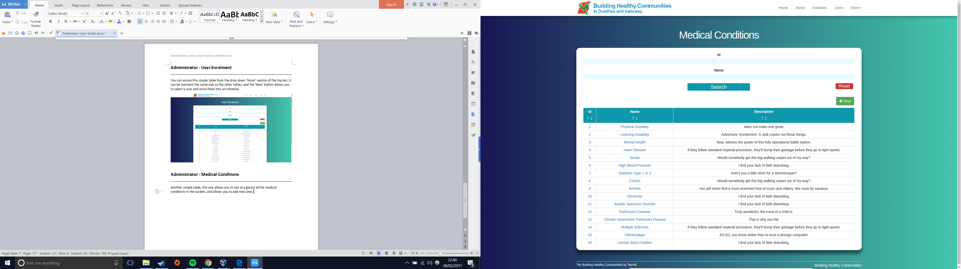

## Administrator - Questions

The final simple table, this one lists all the feedback questions in the system. New ones can be added, and each can be edited, allowing you to choose whether a question is visible in the feedback questionnaires, and whether it is multiple choice.

## Administrator - Profile

The final administrator section is the profile page, which is actually your own user page as can be seen from the users section. Your information can be edited here just as anyone else's.

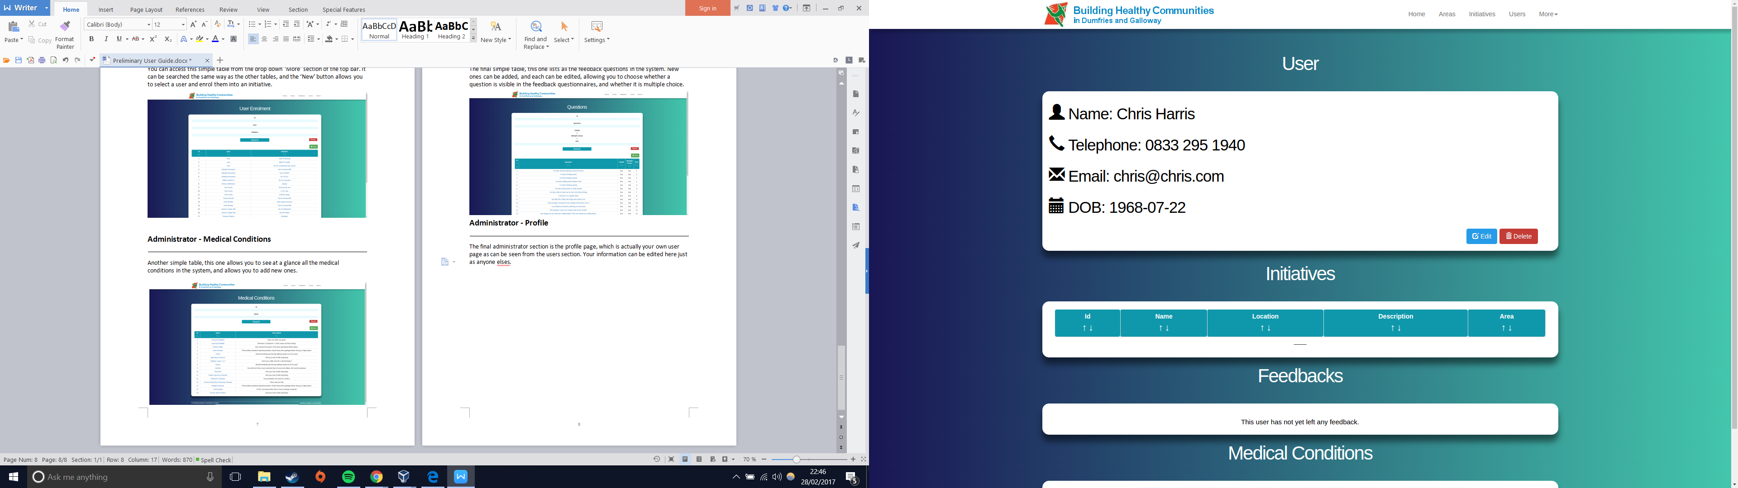

## Volunteers

Don’t worry, the guide is almost over! Volunteers have very little access to the system, only being able to see their own profile page, and initiatives they are part of or volunteer for. As such, logging in as a volunteer shows you a fairly simple homepage, showing initiatives, and a list of members of those initiatives.

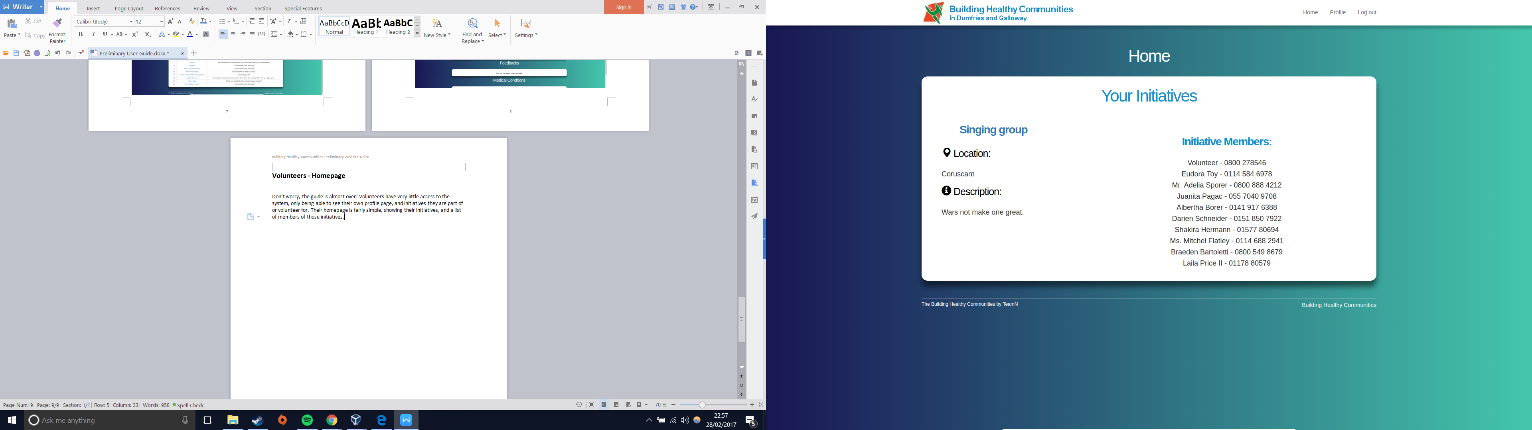

Clicking the name of an initiative takes you to a very similar page to the one described in the Administrators - Initiatives section, with the only difference being that you cannot edit or delete initiatives. You do, however, still retain the power to create new sessions, and take meeting attendance.

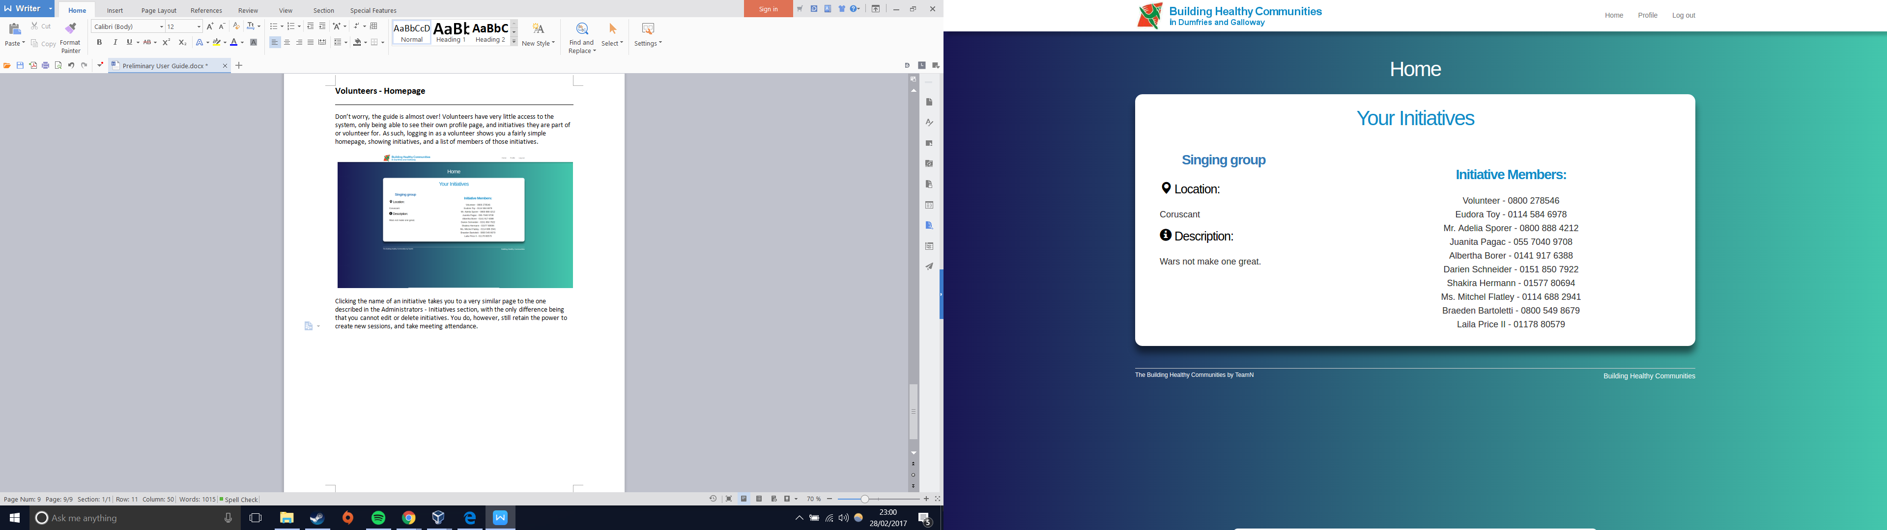

Volunteers also have a profile page, though you can only view the information and not change it. To change information, you should contact an administrator.

## Users

Regular users are the lowest privilege class, having even fewer access rights to the system than volunteers. When you log in as a user, you see a similar homepage to a volunteer, except that instead of a list of members for each initiative, you only see the list of volunteers. Also, you cannot access the initiatives page.

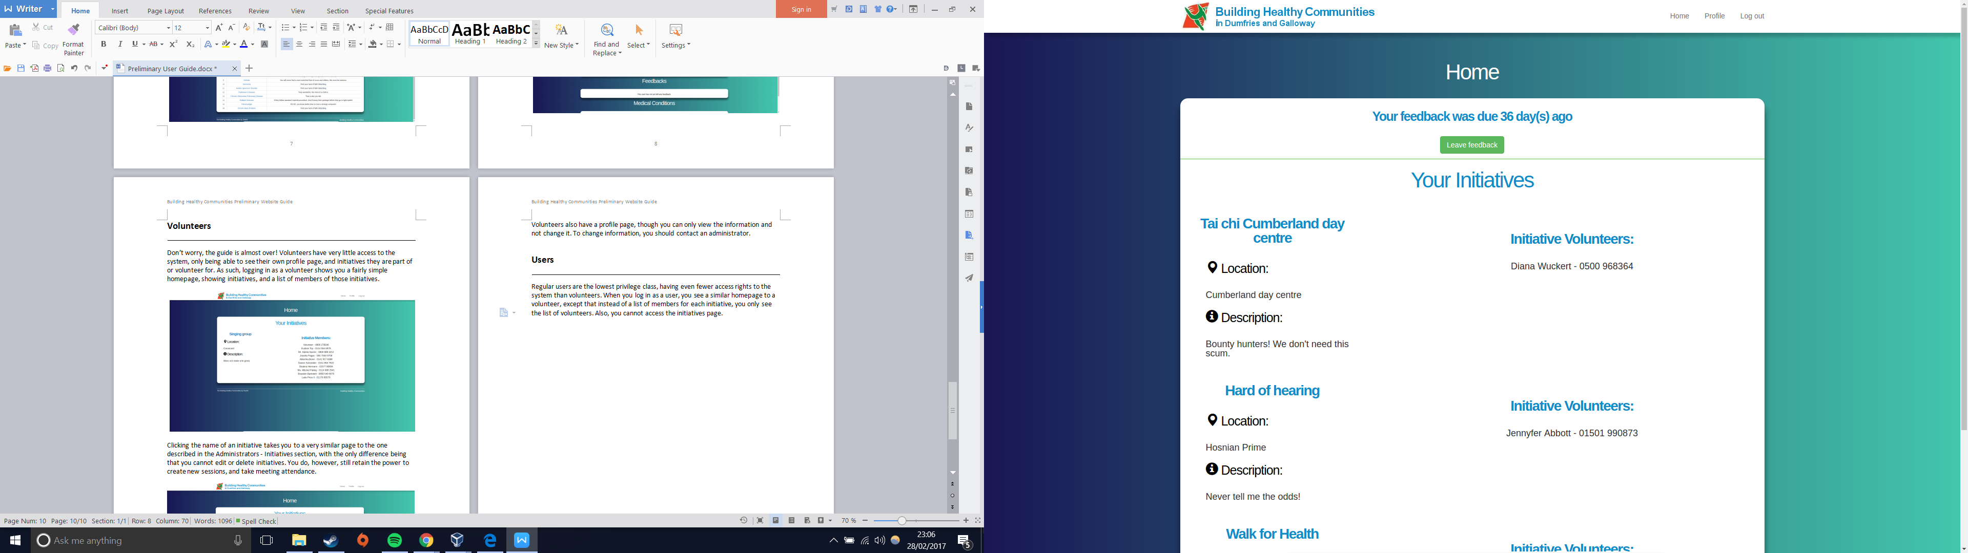

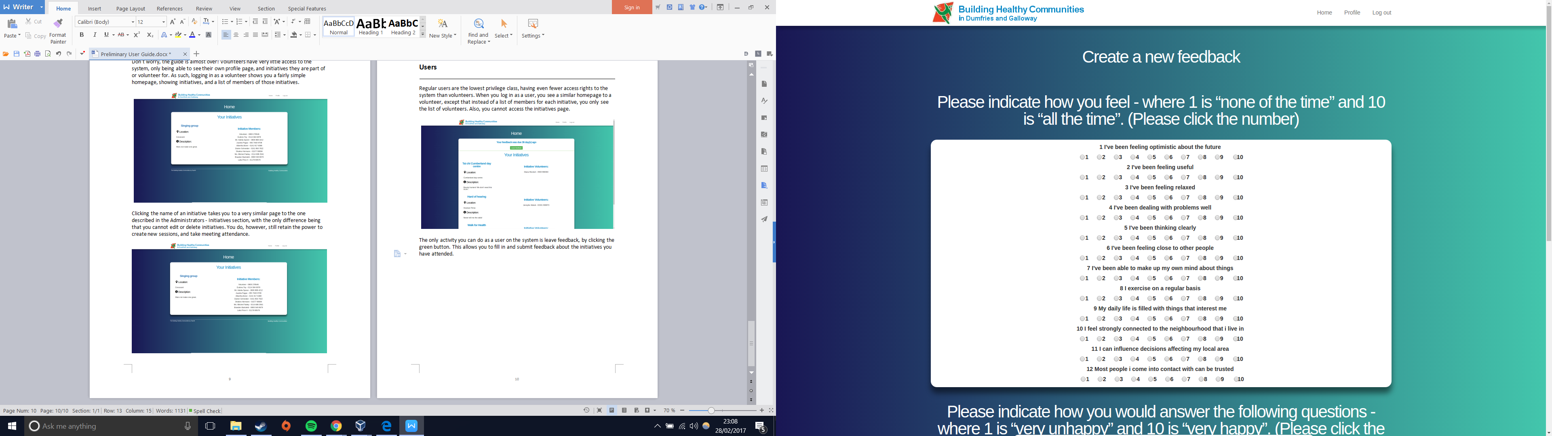The only activity you can do as a user on the system is leave feedback, by clicking the green button. This allows you to fill in and submit feedback about the initiatives you have attended.